Week 4: Flutter Layout

In the labs, you can run your with web browser or phone emulator.

# Lab 1 Comparing: Material vs Non-Material App

## Start with Material App:

1.1 Clone Flutter source from Flutter website

$ git clone <https://github.com/flutter/website.git>

After git clone, folder “website” is created.

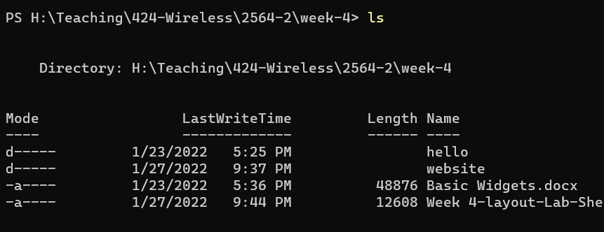

1.2 Create Project with out overwrite

$ flutter create --no-overwrite .\website\examples\layout\base\

1.3 Go to project folder then analyze and test code.

$ cd .\website\examples\layout\base\

$ dart analyze

$ flutter test

$ flutter run

1.4 Capture the output

## 2. Compare with Non-material

Assume we outside website folder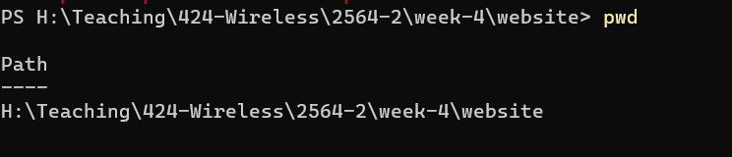

2.1 Create Project based on git clone one, non-material, without overwrite

$ flutter create –-no-overwrite .\examples\layout\non_material\

2.2 Go to Project directory, analyze, test and run

$ cd .\examples\layout\non_material\

$ dart analyze

$ flutter test

$ flutter run

2.3 Capture the result

3. What is the difference between Material APP vs Non-Material App?

# Lab 2 Row and Column Widget

Assume, you have done with Lab 1, so that we have source of Lab 2 already.

## 2.1 Assume we outside website folder

## 2.2 Create Project based on git clone one, non-material, without overwrite

$ flutter create --no-overwrite .\examples\layout\row_column\

## 2.3 Go to Project directory, analyze, test and run

$ cd .\examples\layout\non_material\

$ dart analyze

$ flutter test

$ flutter run

## 2.4 Capture the result

2.5 Question?

On the result, what have to do in main.dart, to let see unseen structure in App.

Exercise 1:

Given lab 2 that show images in Row, change the code (one line), to show image in column.

# 3. Lab Sizing Widgets

Assume, you have done with Lab 1, so that we have source of Lab 3 already.

## 3.1 Assume you can change folder/director to appropriate place,

## in side website folder as before.

## 3.2 Create Project based on git clone one, non-material, without overwrite

$ flutter create --no-overwrite .\examples\layout\sizing\

## 3.3 Go to Project directory, analyze, test and run

$ cd .\examples\layout\sizing\

$ dart analyze

$ flutter test

$ flutter run

## 3.4 Capture the result

# Exercise 2:

Given project in Lab 3, to see Overflow in App change

Line 21 in lib\main.dart, body: Center(child: buildExpandedImages()),

Replace with

body: Center(child: buildOverflowRow()),

Process necessary steps to show Overflow output on App.

If you run App on Brower, resize screen manually to see that is Overflow mea

Capture the Error.

Lab 4: Full Layout Example App

This lab is not elaborate so much, but let student overall result from lecture

Assume, you have done with Lab 1, so that we have source of Lab4 already.

## 4.1 Assume you can change folder/director to appropriate place,

## in side website folder as before.

## 4.2 Create Project based on git clone one, non-material, without overwrite

$ flutter create --no-overwrite .\examples\layout\pavlova\

## 4.3 Go to Project directory, analyze, test and run

$ cd .\examples\layout\pavlova\

$ dart analyze

$ flutter test

$ flutter run

Zoom in or Zoom out in your browser to get ride of Overflow if it show here.

4.4 Prepare information related to your project: your image, Text descript your project, assume this app has been review by some number of user so choose your random one for Reviewer number.

Change three icon relate to your project:

1. Proposal icon: weeks
2. Implementation icon : weeks
3. Verify icon: weeks

## 45 Capture the result

Submit your result as w4_flutter_studentID.pdf